**Supplementary materials for**

**CHAPTER 6**

**of**

***The Biology and Conservation of Animal Populations***

**by John A. Vucetich**

**Contents**

1. **Discussion Points**
2. **Further Reading: elaborations**
3. **Further Reading: case studies**
4. **An Excel-based exercise**

A. **POINTS OF DISCUSSION**

Ideas in Chapter 6 are not best understood through a list of bullet points. Rather, the best way to understand Chapter 6 is through a list of discussion topics:

* Describe the process by which an estimate of extinction risk can be obtained for a population. (You’ll know how to discuss this – for sure – after performing the Excel-based exercise that appears at the end of this document.)
* What are the important lessons to emerge from Figures 6.1? In other words, what are the basic determinants of extinction risk, and how would you characterize the influence of each determinant? Why is Figure 6.1 presented on a log-scale?
* In many cases the assumptions upon which a population viability analysis depends cannot be met. Yet it can still be possible to build a PVA that yields worthwhile insight.
  + How can this be possible?
  + How is the desert tortoise example (p. 108-110) relevant to this topic?
* Consider the topic, universal minimum viable populations (UMVP).
  + On one hand, it is reasonable to conclude that no such value exists. Why?
  + On the other hand, useful insight about MVPs have been gained through the search for a UMVP. What are those insights?
  + How do the insights of Figure 6.2 complement your answer to the previous question?
* Consider the topic, conservation triage.
  + What are the most compelling reasons to support the proactive application of conservation triage?
  + What are the greatest concerns that rise from the proactive application of conservation triage? How are each of these concerns illustrated by the case examples?
* Consider the question, “what is an endangered species?”
  + In what way is that a science question?
  + In what way is that an ethics question?
  + Is extinction risk or geographic extent a better basis for understanding whether a species is endangered or not?

**B. FURTHER READINGS: ELABORATIONS**

Page 128 of Chapter 6 made reference to the “frameworks [of] consequentialism and deontology and their relationship to the biodiversity crisis in the online supplement.” You can get a quick overview of those frameworks with these brief YouTube videos:

[Consequentialism](https://www.youtube.com/watch?v=-a739VjqdSI)

[Deontology](https://www.youtube.com/watch?v=8bIys6JoEDw)

You can get a sense of how those frameworks affect conservation-related judgments in this paper:

Vucetich, J. A., Burnham, D., Johnson, P. J., Loveridge, A. J., Nelson, M. P., Bruskotter, J. T., & Macdonald, D. W. (2019). [The value of argument analysis for understanding ethical considerations pertaining to trophy hunting and lion conservation](https://www.sciencedirect.com/science/article/abs/pii/S0006320718307262). *Biological Conservation*, *235*, 260-272.

Page 128 of Chapter 6 made reference to the psychology of hope and fatalism. You can get a sense of how those frameworks affect conservation-related judgments in this paper:

Ojala, M. (2023). [Hope and climate-change engagement from a psychological perspective](https://www.sciencedirect.com/science/article/pii/S2352250X22002354). *Current Opinion in Psychology*, *49*, 101514.

**C. FURTHER READINGS: CASE STUDIES**

The list of further readings that appears below may also be turned into an assignment that involves students writing a short report on a population viability analysis from the primary literature. Students may be guided to write their reports by suggesting, for example, they organize their reports in a way that includes these sections:

* A **Background** section that introduces the species, summarizes the species’ conservation status, the main threats to the species. Completing this section may require consulting sources beyond your primary source. This section may benefit from photos or maps. This section should be succinctly written and probably be around 75 words.
* **Purpose.** Write a short, substantive paragraph indicating what the authors aimed to learn by conducting the population viability analysis.
* **Methods & Results.** This section should address these topics:
  1. Describe the population model. That is, what features did the model incorporate? Density dependence, age structure, environmental stochasticity, inbreeding?
  2. How were the data gathered?
  3. What PVA scenarios did the authors consider, what parameter settings did they use to represent those scenarios, and what results came from considering those scenarios.
  4. This section may benefit from reproducing graphs or tables from the paper.
* **Authors’ Conclusion,** highlight what the authors say is important about the PVA they performed. This can be a short paragraph, perhaps around 75 words in length.
* The last section should be entitled, **My Impressions**, where you share your impression of the paper. What did you learn, aside from what the authors report as being the paper’s main conclusion? Were any of the results surprising, or were they pretty much intuitive? If the results seemed obvious, was the analysis useful nonetheless? Why? This paragraph can also be short, perhaps around 75 words in length.

1. Haines, A. M., Tewes, M. E., Laack, L. L., Grant, W. E., & Young, J. (2005). [Evaluating recovery strategies for an ocelot (Leopardus pardalis) population in the United States](https://doi.org/10.1016/j.biocon.2005.06.032). *Biological Conservation*, *126*(4), 512-522.
2. Fantle-Lepczyk, J., Taylor, A., Duffy, D. C., Crampton, L. H., & Conant, S. (2018). [Using population viability analysis to evaluate management activities for an endangered Hawaiian endemic, the Puaiohi (Myadestes palmeri)](https://journals.plos.org/plosone/article?id=10.1371/journal.pone.0198952). *Plos one*, *13*(6), e0198952.
3. da Silva, F. A., Canale, G. R., Kierulff, M. C. M., Duarte, G. T., Paglia, A. P., & Bernardo, C. S. (2016). [Hunting, pet trade, and forest size effects on population viability of a critically endangered Neotropical primate, Sapajus xanthosternos](https://doi.org/10.1002/ajp.22565). *American journal of primatology*, *78*(9), 950-960.
4. Murn, C., & Botha, A. (2018). [A clear and present danger: impacts of poisoning on a vulture population and the effect of poison response activities](https://doi.org/10.1017/S0030605316001137). *Oryx*, *52*(3), 552-558.
5. Whitehead, T., Vernes, K., Goosem, M., & Abell, S. E. (2018). [Invasive predators represent the greatest extinction threat to the endangered northern bettong (Bettongia tropica)](https://doi.org/10.1071/WR16103). *Wildlife Research*, *45*(3), 208-219.
6. Smith, J. H., King, T., Campbell, C., Cheyne, S. M., & Nijman, V. (2017). [Modelling population viability of three independent Javan gibbon (Hylobates moloch) populations on Java, Indonesia](https://doi.org/10.1159/000484559). *Folia Primatologica*, *88*(6), 507-522.
7. Hamilton, S., & Baker, G. B. (2016). [Current bycatch levels in Auckland Islands trawl fisheries unlikely to be driving New Zealand sea lion (Phocarctos hookeri) population decline](https://doi.org/10.1002/aqc.2524). *Aquatic Conservation: Marine and Freshwater Ecosystems*, *26*(1), 121-133.
8. Anderson, C. M., Iverson, S. A., Black, A., Mallory, M. L., Hedd, A., Merkel, F., & Provencher, J. F. (2018). [Modelling demographic impacts of a growing Arctic fishery on a seabird population in Canada and Greenland](https://doi.org/10.1016/j.marenvres.2018.09.021). *Marine environmental research*, *142*, 80-90.
9. Soutullo, A., López-López, P., & Urios, V. (2008). [Incorporating spatial structure and stochasticity in endangered Bonelli’s eagle’s population models: implications for conservation and management](https://doi.org/10.1016/j.biocon.2008.01.011). *Biological Conservation*, *141*(4), 1013-1020.
10. Lee, D. E., Fienieg, E., Van Oosterhout, C., Muller, Z., Strauss, M., Carter, K. D., ... & Deacon, F. (2020). [Giraffe translocation population viability analysis](https://doi.org/10.3354/esr01022). *Endangered Species Research*, *41*, 245-252.
11. Taylor, B. D., & Goldingay, R. L. (2013). [Facilitated movement over major roads is required to minimise extinction risk in an urban metapopulation of a gliding mammal](https://doi.org/10.1071/WR12142). *Wildlife Research*, *39*(8), 685-695.
12. Aguiar, L., Brito, D., & Machado, R. B. (2010). [Do current vampire bat (Desmodus rotundus) population control practices pose a threat to Dekeyser's nectar bat's (Lonchophylla dekeyseri) long-term persistence in the Cerrado?.](https://doi.org/10.3161/150811010X537855) *Acta Chiropterologica*, *12*(2), 275-282. (*This is a good paper, but the graphs do a poor job of conveying the results because they present TOO much information. You’ll have to study the graphs and think about what results to present to best convey the results to your audience*.)
13. Davis, R. A., Lohr, C. A., & Dale Roberts, J. (2019). [Frog survival and population viability in an agricultural landscape with a drying climate](https://doi.org/10.1002/1438-390X.1001). *Population Ecology*, *61*(1), 102-112. *This is a great paper and depends on an idea that we’ve not yet covered in class. The idea is: metapopulation. You’ll want to explain to the audience what a metapopulation is and why that idea is relevant. Very simply a metapopulation is a set of several population connected to each other by occasional dispersal*.
14. Dayananda, B., Gray, S., Pike, D., & Webb, J. K. (2016). [Communal nesting under climate change: fitness consequences of higher incubation temperatures for a nocturnal lizard](https://doi.org/10.1111/gcb.13231). *Global Change Biology*, *22*(7), 2405-2414. *Before performing an extinction risk analysis, these authors collected some important empirical data. Doing a good job with this case study will require you to describe these empirical observations and the methods they used to collect that data. This is a great paper. You won’t be disappointed.*
15. Fan, P. F., Ren, G. P., Wang, W., Scott, M. B., Ma, C. Y., Fei, H. L., ... & Zhu, J. G. (2013). [Habitat evaluation and population viability analysis of the last population of cao vit gibbon (Nomascus nasutus): Implications for conservation](https://doi.org/10.1016/j.biocon.2013.02.014). *Biological Conservation*, *161*, 39-47. *Before performing an extinction risk analysis, these authors collected some important empirical data. Doing a good job with this case study will require you to described these empirical observations and the methods they used to collect that data. Very interesting paper – as real-world as it gets.*
16. Cremona, T., Crowther, M. S., & Webb, J. K. (2017). [High mortality and small population size prevent population recovery of a reintroduced mesopredator](https://doi.org/10.1111/acv.12358). *Animal Conservation*, *20*(6), 555-563. *Before performing an extinction risk analysis, these authors collected some important empirical data. Doing a good job with this case study will require you to described these empirical observations and the methods they used to collect that data.*

**D. AN EXCEL-BASED EXERCISE***This exercise is like a workbook. It is a combination of information and work to do in Excel. Passages of text highlighted in yellow help draw your attention to specific work that you should do and submit. The work is divided into sheets. When you are finished you will have an Excel file with several sheets.*

*You can perform your work from scratch, or you can see the Excel file associated with these Supplementary Materials. That Excel file is a template to which you can add your own work. See the file named, Chapter 6 Suppl Matls part 1.xlsx.*

**1. Motivation**

Ocelots, northern spotted owls, and Hawaiian crows are all protected by the U.S. Endangered Species Act (ESA). They are to receive the special protections of the ESA until they are no longer considered endangered species.

The U.S. Fish and Wildlife Service worked in collaboration with other experts to develop recovery plans for these species. Recovery plans have, essentially, the force of law and stipulate conditions under which a species no longer needs the special protections of the ESA. Recovery plans for the abovementioned species indicate that they will be considered recovered and no longer endangered when those populations have less than a 5% probability of extinction in 100 years. Those circumstances raise the question, how does one estimate a population’s extinction risk?

**2. Goal**

Make an Excel file that can calculate a population’s probability of going extinct over a 100-year period of time, given the populations average *r*, variance in *r*, carrying capacity, and initial population size.

**3. Building a PVA in Excel**

In Chapter 2, we learned this equation:

*Nt*+1 = *Nt* + *Ntrt*.

If *rt* is the same value, year-after-year, then the population grows (or declines) exponentially.

Now, suppose that the average value of *rt* is 0.01/year. But sometimes *rt* is a little larger and sometimes a little smaller. And, occasionally *rt* is quite a bit larger or smaller. To account for those fluctuations, we can write:

*Nt*+1 = *Nt* + *Nt* (E[*r*] *+ εt*).

In this equation *rt* is separated into two elements. The first element (E[*r*]) is read “expected value of *r*” and represents the value of *r* that one would expect to see if there is no environmental stochasticity. The second element (*εt*) is the random influence of environmental stochasticity.

Fluctuations in *rt* around the expected value can be described by a series of random numbers drawn from a normal distribution with a mean value of 0 and standard deviation, whose value is represented by the symbol *σ*.

On the next page is a diagram of an Excel spreadsheet that performs the calculations associated with the preceding equation. You should build your own version of this spread sheet. Your sheet should include a graph of the population dynamics. This is the time when you can consult the Excel file associated with these Supplementary Materials.

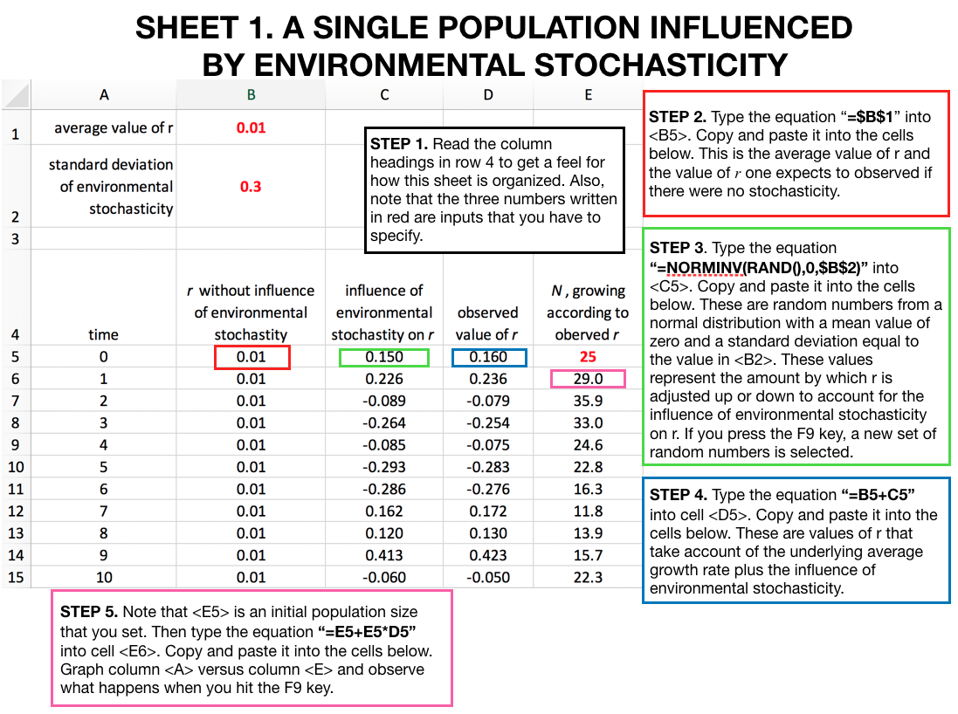

The population’s dynamics depend on a set of random numbers. Because of that circumstance, we’re not so interested in the behavior of a single realization of the population’s simulated dynamics. Rather, what we really want is to understand the properties of many realizations of the population’s simulated dynamics. To gain this understanding, we need an efficient way to simulate many populations – each with the same properties (e.g., same average growth rate, initial population size, etc.). On the next page is a diagram of an Excel sheet that does exactly this. You should build your own version of this spread sheet. Your sheet should include a graph of the population dynamics.

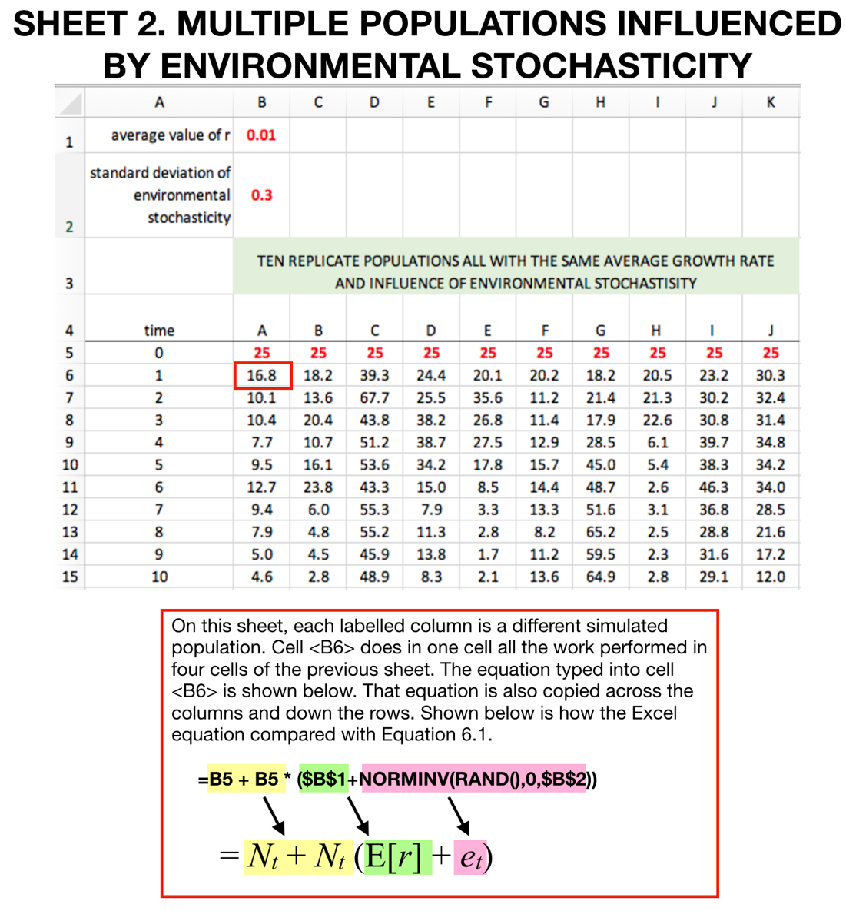

To perform a useful PVA, we need to continue making additional spreadsheets that further modify what we’ve done so far. First, we need to set a threshold, such that as the population’s abundance drops below the threshold (say *N*=2), then the population goes extinct and stays extinct. We need to give Excel specific instructions so that the simulated populations behave that way. On the next page, is a diagram of an Excel sheet that does exactly this. You should build your own version of this spread sheet. Your sheet should include a graph of the population dynamics.

Building this next sheet requires making use of IF( ) statements in Excel. If you are unfamiliar with these statements, now is a good time to look up on the internet how they work.

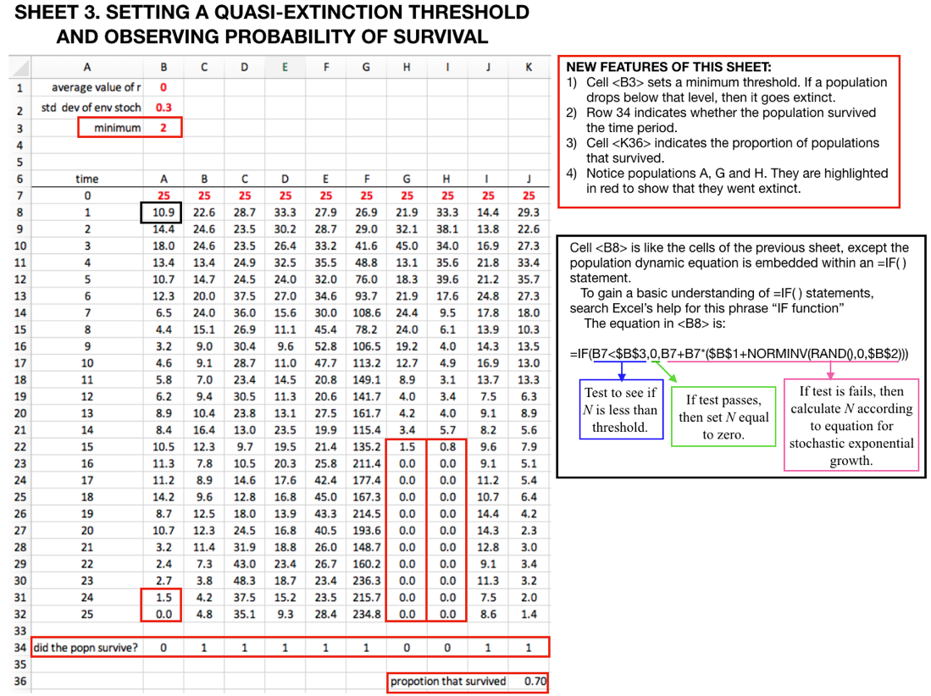

Sheet 3 represents a population that follows this equation:

If *Nt* < 2, then *Nt*+1 = 0,

else  *Nt*+1 = *Nt* + *Nt* (E[*r*] *+ εt*)

We need one more modification to our Excel calculations. As the preceding equation is written, it is possible for the population to grow to infinity. In Chapter 3, we learned about density-dependent equations that prevent populations from growing to infinity. We could incorporate those equations into this Excel sheet. But we will instead do something a bit simpler.

Specifically, we will stipulate a maximum abundance. This is like a carrying capacity, but not exactly. If the equations predicting that abundance should exceed the maximum, then abundance is held at the maximum, year after year, until the equations predict that the population is expected to decline from the maximum.

We can talk about how realistic this assumption is in class. For now, and in a nutshell, if you want to understand population fluctuations near the maximum value, then this is a terrible assumption. But if you want to understand extinction dynamics, then this assumption is very likely not problematic.

The next Excel sheet that we build will have two features: an extinction threshold and a maximum abundance. Mathematicians refer to these as an absorbing boundary and a reflecting boundary. Let’s suppose that the extinction threshold is 2 and the maximum abundance is 100. If so, then the equations that describe the population dynamics are:

If *Nt* < 2, then *Nt*+1 = 0,

If *Nt* > 100, then *Nt*+1 = 100,

else  *Nt*+1 = *Nt* + *Nt* (E[*r*] *+ εt*)

To perform these equations in Excel requires making use of nested

=IF( ) statements. That is, one =IF( ) statement gets placed inside another. If we were to hybridize the notation of the preceding equation and Excel’s notation for =IF( ) statements, then what we’re looking to do is create a statement in Excel that looks like this:

= IF(N < 2, 0, IF(N > 100, 100, *Nt* + *Nt* (E[*r*] *+ εt*))

Excel reads through that equation in this way:

* If *N* is less than two, then set the next value of *N* equal to zero.
* Otherwise, go to the next part of the IF statement, which gives another test. That is, the next part is an IF statement nested within the first IF statement.
* This second test assesses whether *N* is greater than 100. If it is, then it re-sets *N* equal to 100.
* If that second test fails (i.e., if *N* is less or equal to 100), then make a prediction for the next *N* based on stochastic exponential population growth.

Wow, the preceding equation is only 38 characters long, but it performs all the instructions that take more than 75 words to explain in English. This ability to communicate instructions so compactly is a real value of mathematical equations (and computer code).

You should build your own version of a spread sheet that does what is described in the preceding equation. The overall appearance of the sheet will be identical to what you developed for sheet 3. The only difference is that the main formula within many of the cells will look like this:

=IF(B7<$B$3, 0, IF(B7>$B$4, $B$4, B7+B7*($B$1+NORMINV(RAND(),0,$B$2))))

Note that the details of your formula may vary depending on which cells you use to store the extinction threshold, the maximum population size, and the previous year’s abundance. In any case, what is written above is the correct structure for your formula.

**4. Recreating a portion of Figure 6.2 from Chapter 6.**

Use the PVA that you created on the fourth sheet of your Excel file to recreate the line for E[r]=0 as it appears in the left panel of Figure 6.2. The values of *No* to use should be: 30, 60, 90, 150, 180, 240, 300, 600, 900, 1200, 1500, 2100, 2700, 3000. That list of numbers will result in a graph that has a sufficiently even spread of values after log-scaling the x-axis of your graph.

When you perform this analysis, each estimate of extinction risk (for each value of *N*) should be based on 1000 replicate populations. The way to do so is to expand the fourth sheet of your Excel file to include 100 replicate populations and then use the F9 key. Each time you strike the F9 key, Excel produces a new set of random values. If you strike the F9 key ten times, recording the result with each strike, then you’ll have the necessary information for an estimated based on 1000 replicates.

**5. Assessing extinction risk for Ocelots**

This next step is loosely based on this paper:

*Haines et al. (2005). Evaluating recovery strategies for an ocelot (Leopardus pardalis) population in the United States.* ***Biological Conservation****, 126(4), 512-522.*

To get a little background on this case, I recommend reading the introduction of this paper. Finding papers like this should be a skill that you have by now. If you have trouble finding this paper, then you definitely want to ask for help from your instructor or university librarian.

There is a population of ocelots on the Texas-Mexico border. It has 35 individuals. Currently available habitat probably limits the population to no more than about 50 individuals. The population also has an average annual per capita growth rate of 0.01/yr and a standard deviation in growth rate of 0.2.

Suppose that the U.S. Fish and Wildlife Service has decided that the population will be considered recovered if the population has a 5% (or less) risk of going extinct over the next 100 years. Further suppose that you are hired to advise the USFWS on what actions should be taken to achieve that risk of extinction. More specifically, perform analyses that can answer these questions:

* What is the probability of extinction for this population over the next 100 years?
* If one could double or triple the habitat available to this population, would that be enough to reduce the risk of extinction to 5% or less over a hundred-year period?
* If one doubled habitat and augmented the population with captive individuals so that its starting size is 60 individuals, would that be enough to reduce the risk of extinction to 5% or less over a hundred-year period?
* If maximum speed limits within ocelot habitat were reduced by 10 mph, it is thought that mortality due to car collisions would be reduced and the annual per capita growth rate would increase to 0.03/year. Suppose that a 10-mph reduction in speed limit is implemented along with a doubling of habitat and releasing enough captive ocelots to bring the initial population size to 60 individuals. Would that be enough to reduce extinction risk to 5% or less over a hundred-year period?

Prepare a short report in a Word document that describes the findings of your analysis of ocelot extinction risk. The report should be as long as you need it to be to explain your results. I’d guess you can do this in 2-4 short paragraphs. Your report should also include graphs that support your analysis.