**Supplementary materials for**

**CHAPTER 8**

**of**

***The Biology and Conservation of Animal Populations***

**by John A. Vucetich**

**Contents**

1. **Summary and Points of Discussion**
2. **Further Reading**
3. **Activities**

**A. SUMMARY AND POINTS OF DISCUSSION**

* When humans exploit an animal population it is generally important to evaluate the exploitation. For example, were the goals of exploitation met? Were undesirable outcomes avoided? Was the exploitation successfully planned and executed? Pages 168-170 explain why it is difficult to perform such an evaluation. In your own words, why is it difficult?
* HARVESTING UNSTRUCTURED POPULATIONS:   
  Page 171-186 explain how exploitation can be evaluated – in a quantitative sense. This evaluation involves examining the trade-offs associated with various kinds of harvest strategies when they are implemented at various intensities. To this end, be able to:
  + Describe each of the four harvest strategies covered in this section.
  + Figure 8.2 shows that a population exposed to the constant quota strategy equilibrates to some positive value (that is less than K) for a wide range of starting abundances. But if the starting abundance is too low, the population declines to zero. Why is this? Hint: the answer comes from being able to explain Figure 8.3.
  + How are Figures 8.2 and 8.3 relevant to understanding the risk of overexploitation in real populations?
  + Figure 8.4 depicts several strategies that are likely to be safer than the strategy depicted in Figure 8.3.
    - Why are those strategies likely to be safer? Provide an answer by making reference to the unstable equilibrium that characterized Figure 8.3.
    - Are there any downsides or limitations of using these safer harvest strategies?
    - Is there any way that the riskier strategy shown in Figure 8.3 can be made safer?
  + Figure 8.7 compared the four harvest strategies for populations that experience density-dependent growth and environmental stochasticity.
    - Describe how Figure 8.7 was constructed.
    - According to Figure 8.7, which strategy is best?
  + What is the insight conveyed by Figure 8.8?
  + What are the general lessons to learn from quantitative comparisons of modeling the effects of different harvest strategies? (Hint: see p. 184-186.)
* HARVESTING STRUCTURED POPULATIONS:
  + Without looking at the chapter, draw a life cycle diagram that accounts for both the sex and age-related stages of individuals in a population. Suppose that this population is well represented by four age-related stages. Write out a projection matrix for this same population.
  + An overly simple lesson to learn from models that describe the harvest of structured populations is (p. 191):   
     males of a polygynous population can be harvested intensely without much   
     impact on the population’s growth rate or abundance. Conversely, population   
     dynamics are far more sensitive to harvest strategies that focus on the   
     females of a polygynous population.  
    How do the examples on pages 191-193 illustrate the need to take a more nuanced understanding of harvest in structured populations?
* The basics of harvesting unstructured and structured populations are covered by pages 168-193. Pages 194-205 cover additional topics that apply to harvesting both kinds of populations.
  + Compensatory mortality: What is compensatory mortality? How can the presence of compensatory mortality be evaluated? What kinds of ecological conditions tend to favor the presence of compensatory mortality?
  + Aside from the demographic impacts, how else can harvest affect a population? Give examples.
  + Pages 197-201 include these sections: (i) Resiliency to Overharvest, (ii) Risk of Overexploitation, and (iii) Overconfidence. Thinking of these sections as a set and in your own words, summarize the main lessons of those sections.
* The opening pages of Chapter 8 (p. 168-170) explain how and why it can be difficult to plan and evaluate the harvest of an animal population. The last three sections of Chapter 8 (p. 201-205) revisit this topic. Given all that you’ve learned about harvesting, how would you summarize those last three sections?

**B. FURTHER READING**

Simard, M. A., Dussault, C., Huot, J., & Côté, S. D. (2013). [Is hunting an effective tool to control overabundant deer? A test using an experimental approach](https://wildlife.onlinelibrary.wiley.com/doi/abs/10.1002/jwmg.477). *The Journal of Wildlife Management*, *77*(2), 254-269.

Vucetich, J. A., Bruskotter, J. T., Nelson, M. P., Peterson, R. O., & Bump, J. K. (2017). [Evaluating the principles of wildlife conservation: a case study of wolf (Canis lupus) hunting in Michigan, United States](https://academic.oup.com/jmammal/article/98/1/53/2977229). *Journal of Mammalogy*, *98*(1), 53-64.

Wilson, JW and RB Primack. 2019. [Overharvesting](https://bio.libretexts.org/@go/page/26793). Original source: <https://doi.org/10.11647/OBP.0177>.

Lindsey, P. A., Balme, G., Becker, M., Begg, C., Bento, C., Bocchino, C., ... & Zisadza-Gandiwa, P. (2013). [The bushmeat trade in African savannas: Impacts, drivers, and possible solutions](https://www.sciencedirect.com/science/article/pii/S0006320712005186). *Biological conservation*, *160*, 80-96.

Packer, C., Brink, H., Kissui, B. M., Maliti, H., Kushnir, H., & Caro, T. (2011). [Effects of trophy hunting on lion and leopard populations in Tanzania](https://conbio.onlinelibrary.wiley.com/doi/abs/10.1111/j.1523-1739.2010.01576.x). *Conservation Biology*, *25*(1), 142-153.

Here are a set of YouTube videos on the overexploitation of cod in the North Atlantic:

* This one focusses on the [social impact of the collapse](https://www.youtube.com/watch?v=0sFmT8IXGhw&t=12s).
* This one focuses on the [political influences involved in fisheries management](https://www.youtube.com/watch?v=Egkky6vqeN0&t=4s).
* This one focuses on the [economic drivers of overexploitation](https://www.youtube.com/watch?v=7DNhqtYf47E&t=18s).

**C. ACTIVITIES**

1. **REPRODUCING FIGURES 8.2 and 8.3 OF THE TEXTBOOK**. This exercise guides you in building a spreadsheet that results in Figures 8.2 and 8.3 of the textbook. First open the spreadsheet entitled, “Chapter 8 Suppl Matls.xlsx” and go to the sheet labeled “Figs 8.2 & 8.3.” Now let’s get oriented to portions of the sheet that are already filled out:
2. 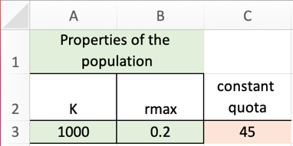The upper left portion of the sheet are inputs referred to in other portions of the sheet, specifically, a carrying capacity (K), rmax, and number to be harvested each year (quota).
3. 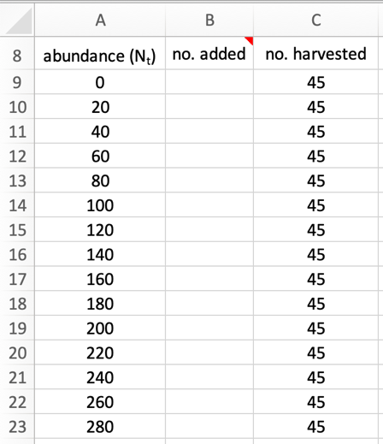Just below those input settings are three columns that we’ll use to make a graph like Figure 8.3. The **first column** represents the x-axis of our graph, which will be different possible abundances of the population. For this column we just want a series of numbers going from zero to *K*. The **third column** indicates how many individuals are harvested each year; these values are referenced to cell <C3>.   
    With respect to the **second column**, your job is to write an appropriate equation into cell <B9>. Then copy and paste that equation into the cells beneath. When you do the top graph in columns <D> through <I> will be created automatically.  
    What you need to type into cell <B9> is an equation that predicts the number of individuals added to the population (in the absence of any harvest), given its size (*Nt*), carrying capacity (*K*) and maximum growth rate (*rmax*). That equation is:  
    *Nt*+1 – *Nt* = *Ntrmax*(1 – *Nt*/*K*)

You can derive this equation from Eqn 3.3 in Chapter 3, and then subtract *Nt* from both sides of that equation. This equation is also the same as Eqn 8.1, except that it does not include a term to represent removals due to harvest.   
 When you type this equation into cell <B9> be sure to use hard references ($) in a manner that references the cells <A3:C3> in a sensible way. Now is a good time to complete the cells in this second column.

1. 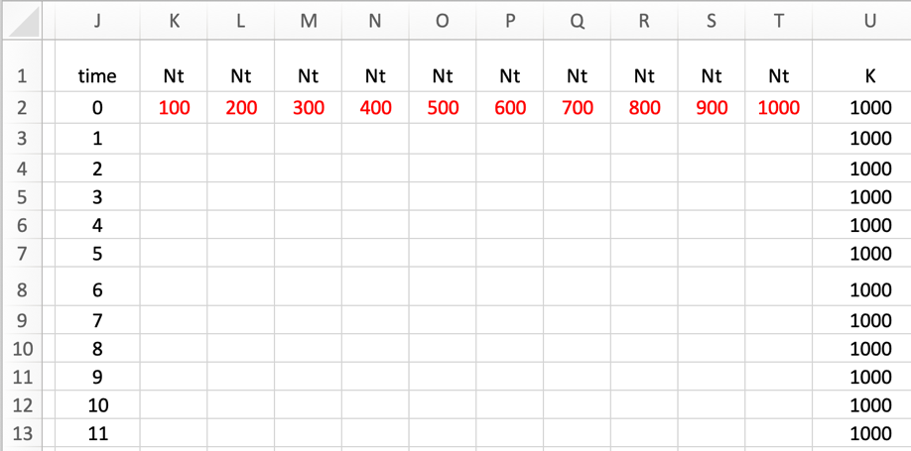Now draw your attention to columns <J> through <U>. In these columns we’ll create 10 time series of abundances. Each time series will represent a population’s abundance, given the input values in cells <A3:C3>. But each time series will have a different starting abundance. Those different starting abundances are given in red (row <2>). Your job is to place appropriate equations in cells <K3:T52>. When you do, the second graph in columns <D> through <I> will be created.
2. The equation you are looking to type into cell K3 is related to Eqn 8.3, which is:

*Nt*+1 – *Nt* = *Ntrmax*(1 – *Nt*/*K*) – *H*  
But, if you were to type that equation into this block of cells, there would be a problem. Specifically, this equation will allow the population size to become negative if the harvest is too large. To fix this problem, we want to modify the equation that gets typed into this block of cells so that predicts abundance according to Eqn 8.3, unless it predicts a negative abundance. In that case, we just want Excel to report that the population size is zero.   
 To do this, we’ll make use of the Excel function =MAX(). The function works by giving Excel two values; it returns the larger value. For example, if you type   
 =MAX(-12,0)

into a cell, the computer will report a value of zero.

What you want to do is replace “-12” in the example I just gave in the preceding paragraph with an expression that represents Eqn 8.3.   
 If you insert hard references in the correct places, you can copy your equation into all the remaining cells in the region <K3:T52>. When you do so, the second graph in columns <D> through <I> will look like Figure 8.2.

1. **BETTER UNDERTSANDING HOW FIGURE 8.7 WAS CONSTRUCTED.** Recall from Chapter 6 (and the Supplementary Materials associated with Chapter 6) that we developed an Excel spreadsheet to assess extinction risk in a population exposed to environmental stochasticity. That spread sheet involved creating many time series of abundances, where each time series was characterized by (i) the same set of input parameters (K, No, etc.) and (ii) a different set of random numbers to represent the influence of environmental stochasticity. Then we examined the tendencies exhibited by the entire set of time series.   
    In this exercise, we’ll do something similar, except here the population will have density-dependent growth and be exposed to a harvest. We’ll do this work in the Excel file associated with these supplementary materials on the sheets labelled “constant quota” and “constant proportion.”

First, let’s get oriented to the different parts of the sheet labelled “constant quota.” The

upper left portion of this sheet looks like this:

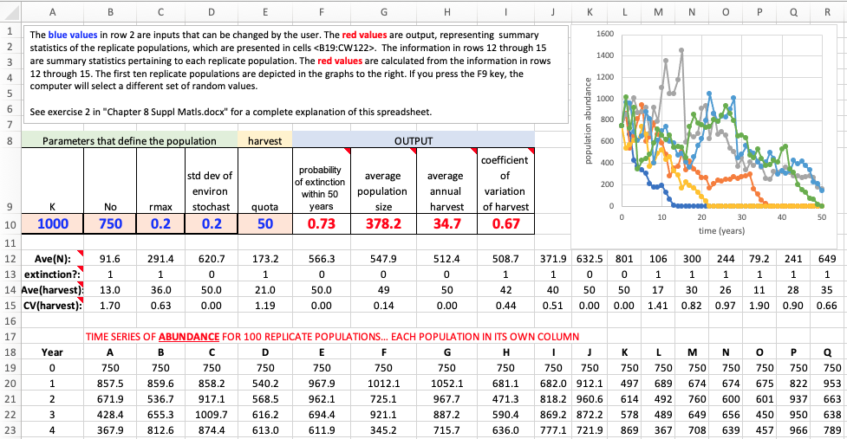

* The **blue values** in row 2 are inputs that can be changed by the user.
* The **red values** are outputs, representing summary statistics of the replicate populations, which are presented in cells <A19:CW122>.
* Notice cell <F9>. It has a little red triangle in the upper corner. Hover on that cell and a comment will appear. This is so for all the cells on this sheet with a red triangle. These comments contain additional information.
* The information in rows 12 through 15 are summary statistics pertaining to each replicate population. The **red values** are calculated from the information in rows 12 through 15.
* The first ten replicate populations are depicted in the graph to the right.
* If you press the F9 key, the computer will select a different set of random values.
* Scroll all the way down to a large block of cells at <A72:CW122>. These cells report how many animals were harvested from each replicate population, each year.
  + If the population’s abundance for any particular year is greater than the quota (which is set in cell <E9>), then the number harvested that year is the quota.
  + If the population’s abundance is less than the quota, then the population goes extinct and the number harvested from that point forward is zero.
  + This block of values may seem to be not especially interesting (because all the cells are either zero or the value of the quota), but you’ll better see how interesting this block is when we work with the sheet representing the “constant proportion” harvest strategy.
  + Go to cell <T1>. There you’ll see a graph depicting the time series of harvest numbers for the first ten replicate populations.

After you have explored this sheet a bit, you can begin exploring the next sheet labeled, “constant proportion.” This sheet is set up very similarly. The main difference is that the populations in this sheet are harvested according to a constant proportion.

On your own, or with your instructor’s guidance, you can see – for each of the two harvest strategies – how the different **outputs** (such as average harvest return or extinction risk) are affected by changing the different **inputs** (such as the amount of stochasticity or the intensity of the harvest). If you explore this relationship between inputs and outputs in a sufficiently systematic manner and graph the results, then you will be creating a graph very much like Figure 8.7.